LAB 6
8-bit Ripple Carry Adder

Due:

PROJECT DESCRIPTION

Use 8 instances of the Full Adder created in Lab 3 to make an 8-bit Ripple Carry Adder.

Read the section of chapter 5 part 2 entitled Ripple-Carry Adder at the bottom of page 240 for an explanation of the Ripple Carry Adder.

Step1: Create a Lab 6 project.

Step 2: Ensure the Implementation Radio button is enabled and then right click in the Design window. Select Add Copy of Source… to import copies of the source modules from Lab 2 into Lab 6
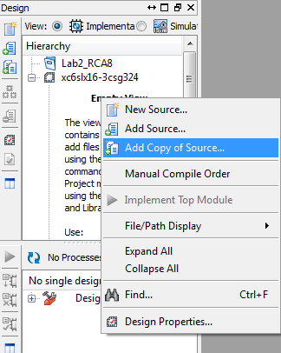

Browse to where your FullAdder.v and HalfAdder.v are contained on your computer. Select them and click Open.
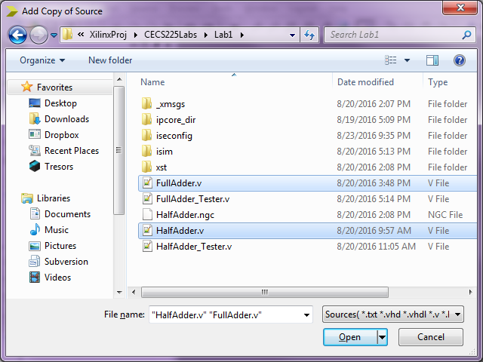
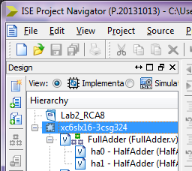
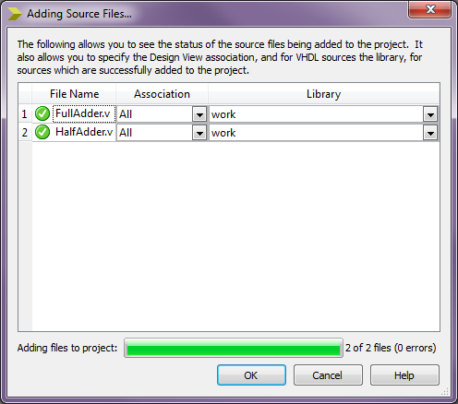
Click OK when the confirmation window on the left is shown and the Verilog modules will be added to your project.

Step3: Create a new Verilog source file named RCA8 which will be used to define an 8-bit Ripple Carry Adder.
RCA8 will have:
- two 8-bit inputs A_8, B_8
- a 1-bit input Cin
- a 1-bit output Cout
- an 8-bit output S_8

The bit width of the input and output port signals are indicated on the block diagram below:
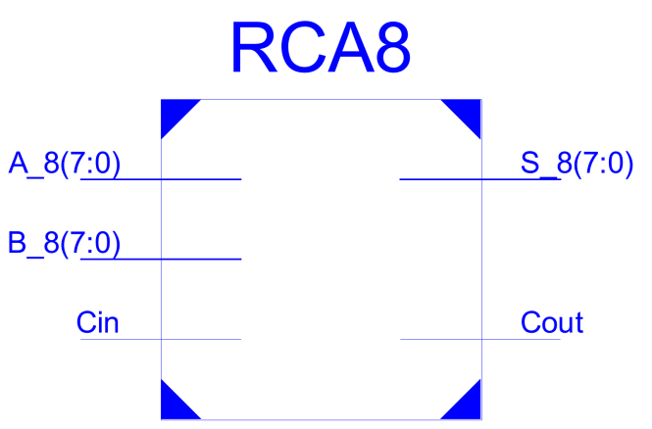

The internal structure of the RCA8 module follows Figure 5.5 of the textbook however there will only be eight Full Adders( numbered 0 through 7) tied together.

Ripple Carry Adder Diagram

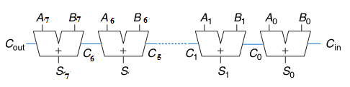
fa0
fa1
fa6
fa7

Instance labels fa0 through fa7 are used to identify the eight full adders. The dotted line in the middle hides the details of how Full Adders fa2 through fa5 are connected but the connections can be determined by finding the connectivity pattern.
Here is a single Full adder for your reference:

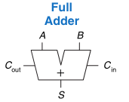
Use the Verilog technique known as module instantiation to create 8 instances of the FullAdder module and connect them according to the Ripple Carry Adder diagram on the previous page. Skeleton code is provided for you to use.
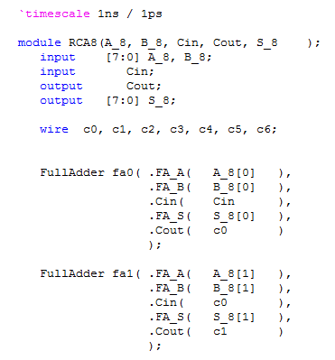
Eight bit inputs and outputs are declared using the vector notation [7:0]. Signals without a vector default to 1-bit.

Wires c0 through c6 are declared to create internal module connections. Each can carry 1-bit of data.
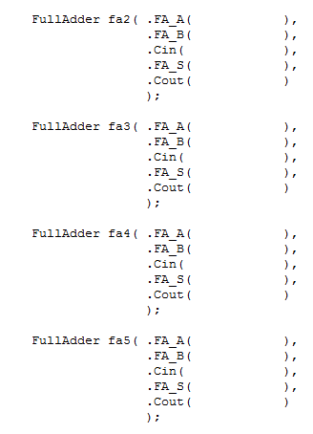
The port lists must be filled in for these FullAdder instances
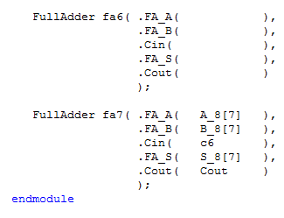
One more port list to fill
When the RCA8 Verilog module is complete, save your RCA8 Verilog module and multiple listings of the Full Adder should now be displayed in your project window. This is to show that the RCA8 calls multiple instances of FullAdder in hierarchical fashion.

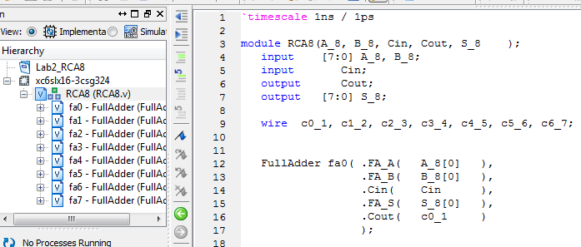

. Also you should see no errors indicated in the console:

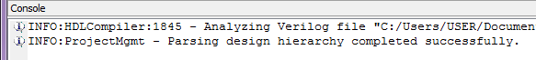

Step4: Make a Verilog test fixture to test the RCA8. Ensure your verilog test fixture is associated with the RCA8 verilog source file as shown below:
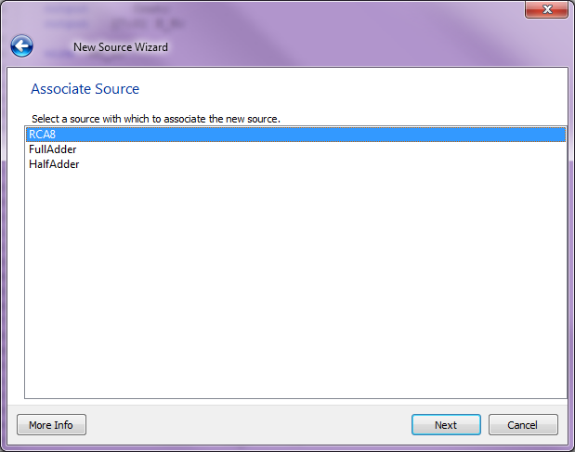
Use the following Test cases. Calculate Output values for Cout and S_8. Then write a test script and see if the values you have calculated match your simulation results:
Inputs |  |  |  | Outputs
Test Case | Cin | A_8 | B_8 | Cout | S_8
0 | 0 | 12 | 34
1 | 0 | 55 | AA
2 | 0 | 72 | 27
3 | 0 | 80 | 08
4 | 1 | 12 | 34
5 | 1 | 55 | AA
6 | 1 | 72 | 27
7 | 1 | 80 | 08

When interpreting the simulation results it is more convenient work with hexadecimal for evaluating multi-bit quantities. Initially test results are shown in binary:
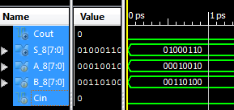

To display data in hexadecimal:
- Ensure all the signals are selected as indicated by the blue highlight.
- Right click on blue highlighted area to bring up a context menu
- Move your mouse down to the Radix menu item
- Select Hexadecimal from the Radix sub-menu
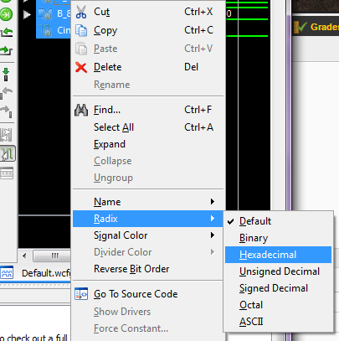
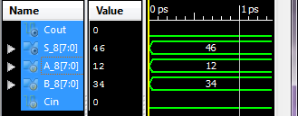
Now multi-bit data will be shown in hexadecimal.
Be sure to use the $stop; system call at the end of the test script in your Verilog test fixture so that your simulation does not go on for longer than it needs.

Once you the calculated outputs values for the sum S_8 and the Carry out Cout match the output values shown in simulation take a single screenshot of the simulation to be included with your Lab report.

Your simulation should run for 80nano-seconds as shown in the image below:
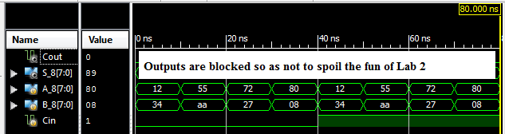

Save all the Verilog Source Files in this project as they will be used in future projects.

Lab 6 Report: Submit a single PDF to beachboard with the following contents.
- Title Page
  - CECS 225
  - Lab 6
  - Your Name
- Section 1: RCA8 Verilog module source
- Section 2: Test Cases Table
- Section 3: RCA8 Verilog Test Fixture
- Section 4: Simulation Screenshot showing correct results

Put each section at the beginning of a new page.

